The Stock Momentum Dashboard
yfinance/Yahoo/Excel Version
Peter Staadecker, 8-Jan-2026
Updated for files:
stock momentum dashboard v10.py
and
stock momentum dashboard v10.xlsx

Contents
The Stock Momentum Dashboard 1
Disclaimer 2
Program Purpose 2
A. Illustration: Sample Input and Output 3
Program Requirements 4
Alternative Version 4
How Stock Prices Are Obtained 4
Personalizing the Program 5
B. Illustration: Confirming Yahoo’s Ticker/Exchange Acronym 5
Running the Program 7
C. Illustration: Typical Messages in the Run Window of the Python Development Environment 7
Approximations 8
FAQs 8

Disclaimer

While I find this program useful for my own purposes, I show it here without any guarantee of correctness, usefulness or anything else. Nor is the program intended as trading advice.
The stocks and ETF tickers I show in this documentation are random examples to illustrate the functioning of the program. They are chosen merely to illustrate the program’s function and are not my stock picks nor trading advice of any kind.
Furthermore, this program relies on a Python financial library called “yfinance” and its interface with Yahoo. Should either change, this program may cease to function.

Program Purpose
This program allows you to input a list of stock or ETF ticker symbols into an Excel spreadsheet. For each ticker entered the program will calculate the annualized percentage price changes over the previous 1, 3, 6 and 12 months.
If you optionally also input a purchase date and purchase price for a ticker, the program will calculate the annualized percentage price change since the purchase date.
This gives a handy, colour-coded overview of stocks that have a positive price trend over time, versus stocks whose prices are turning negative or have mixed results.
I think of these results as a momentum dashboard for stock/ETF prices.
The dashboard uses an Excel spreadsheet both for you to input your choice of ticker symbols and for easy display of the annualized percentage price changes over the above periods.
See the sample screenshot below:

Illustration: Sample Input and Output

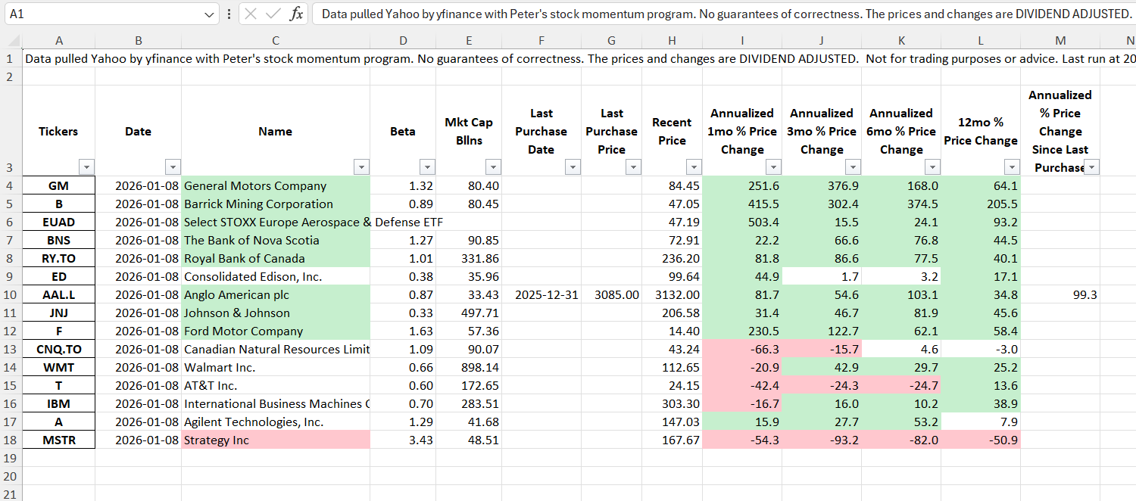

To use the program, you will need Excel and basic familiarity with Excel. You will also need internet access to Yahoo’s financial web pages.
For easy overview, the dashboard is colour-coded, as can be seen in the sample screenshot above.
- Green means the annualized percentage price changes exceed 10%.
- Red means the annualized percentage price changes are less than -10%.
- Black means the annualized price changes are between -10% and +10%.
For the stock/ETF names:
- Red means the 1, 3, 6 and 12-month changes are all negative.
- Green means the 1, 3, 6 and 12-month changes are all positive.
- Black means the 1, 3, 6 and 12-month changes are a mix of some positive, some negative.
The percentage price change since the last purchase date is not coloured and does not influence the ticker colour, since recently bought stocks/ETFs can have very volatile price swings to either plus or minus without any long-term significance.

Program Requirements

You will need Excel and access to the internet.
I have built and tested the program on a PC with the desktop version of Excel 2024, but believe it should work similarly on other devices and other Excel versions.

Alternative Version

On GitHub, I have placed a similar program that runs with Google Sheets using Google’s googlefinance function to look up stock prices. That version may be more suitable if you do not have access to Excel.
As long as the yfinance/Yahoo interfaces continue to function without change, I prefer this yfinance/Yahoo/Excel version because the Google version uses stock prices that are not adjusted for dividends. The Yahoo prices are dividend-adjusted and should be more accurate for purposes of showing stock momentum.

How Stock Prices Are Obtained

The python library, yfinance, pulls the core pricing information for the program from yahoo.com. That functionality requires an internet connection.
This program is intended for personal use only. You should refer to Yahoo’s terms of use for details on your rights to use the data downloaded to your Excel sheet from Yahoo.
yfinance and this program provide beta values and market caps from Yahoo (where available). They also provide Yahoo’s recent stock/ETF prices for your chosen ticker symbols. Yahoo usually delays recent prices by about 15 minutes if the exchange is open and the stocks are trading. yfinance and this program also provide Yahoo’s adjusted closing prices for the previous 1, 3, 6 and 12 months for the tickers of your choice. This program then calculates the annualized percentage changes from these various past periods to the most recent price.
Although the most recent price might be from 15 minutes ago, this depends on whether the market is open or closed and can also be affected by weekends and statutory holidays, and statutory holidays vary by stock exchange and stock exchange jurisdiction. For clarity, the date and time of the recent price are shown for each ticker in column B of the spreadsheet after the program has run.

Personalizing the Program

The GitHub version, which is a fully functional version and you can further modify with tickers of your choice, is called “stock momentum dashboard v10.py” and the accompanying required Excel worksheet, is “stock momentum dashboard v10.xlsx”.
You need to make your own copies of both.
The name and the directory path of the Excel file are hardcoded in the python program. Find the line and change file name and path as needed from
“file_name = r"D:\Users\rpsco\Documents\software\python\python stock screeners\stock momentum dashboard for github\stock momentum dashboard v10.xlsx" to your name and path. Make the corresponding change to the location of your Excel file and name on your device.
Within your copy of the Excel spreadsheet:
- Do not change the spreadsheet structure. If you do, the program will not function correctly.
- You may replace any and all of the provided sample stock/ETF tickers and any purchase dates and prices with your own choices.
- To preserve the row boundaries of the ticker list, you may insert/delete tickers and rows anywhere EXCEPT the first and last row of the current ticker list. You can, of course, change the stock tickers and optionally any purchase dates in the first and last row of the ticker list. Just don’t add/delete rows there.
- Any stock/ETF tickers that you add should be in the format that Yahoo’s financial page recognizes. You can easily confirm these on Yahoo’s financial pages as shown below:

Illustration: Confirming Yahoo’s Ticker/Exchange Acronym

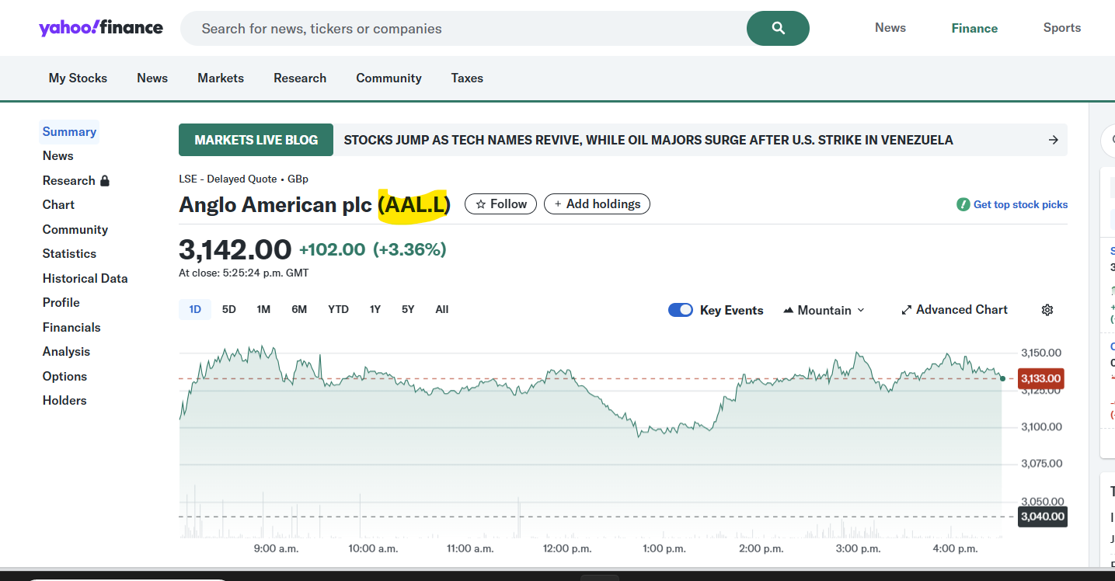

- Ticker symbols should be upper-case.
- After entering your tickers and any previous purchase dates and prices, make a backup copy of your spreadsheet. Reason: each time you run the program it reads your information (tickers, previous purchases, etc.) from your spreadsheet. Then, after calculating new information it overwrites your spreadsheet with an updated version. If anything goes wrong, you’ll lose your input data.
- Save and CLOSE your spreadsheet before running the python program

Running the Program

Make sure the spreadsheet is saved and closed. The python program cannot write its latest results into the spreadsheet if the spreadsheet is open, and the python program will terminate with an access error.

Run your python program from whatever development environment you normally use. In my, case I use PyCharm. The “run” window in my development environment will display various information while the program is running, including a reddish-brown message every time the yfinance routines execute. Despite the red-brown colour, this is not an error message. PyCharm then displays some intermediate calculations, and finally, if all has finished correctly, it displays the message “Process finished with exit code 0”.

The program then automatically opens the Excel spreadsheet for you.

Illustration: Typical Messages in the Run Window of the Python Development Environment

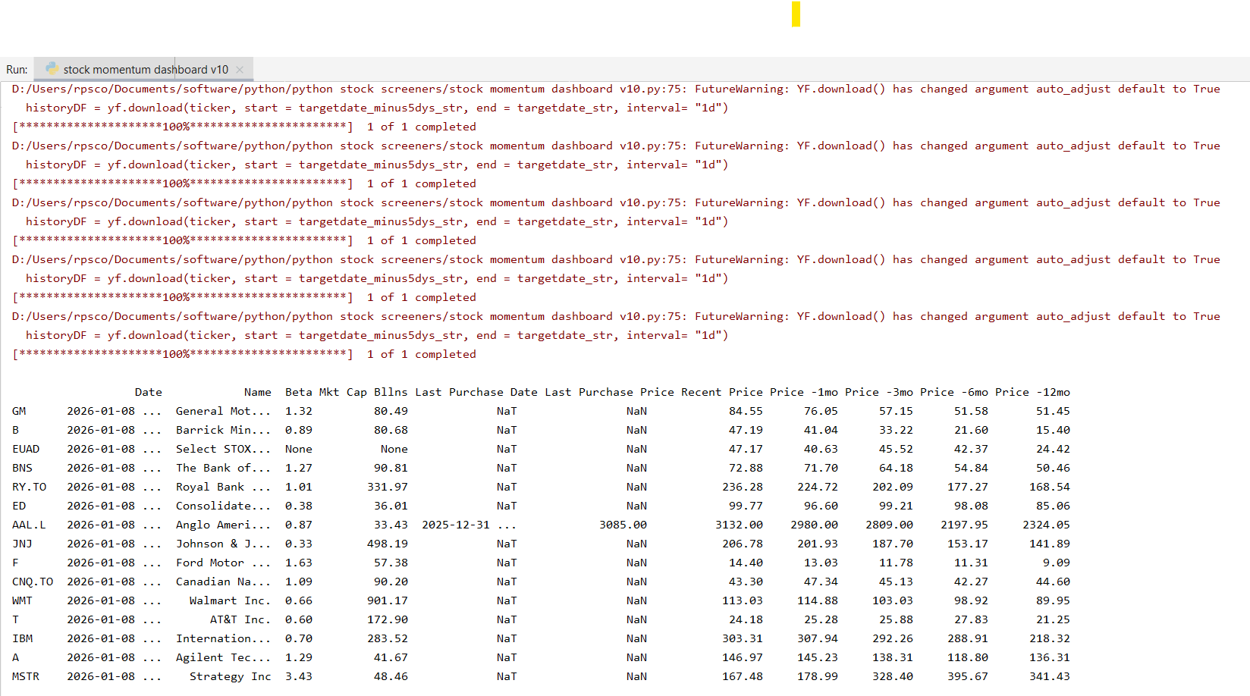

The program takes approximately one sec per ticker name that you have input, but of course, this also depends on the speed of your CPU and your internet access speed.

Approximations

Amongst other approximations, the program takes the 1-month, 3-month, and 6-month percent price changes and converts them to annualized percentage price changes by raising them respectively to the powers of 12, 4 and 2. That is done irrespective of the actual length of the number of days in the actual 1-month, 3-month and 6-month periods involved.
Also, when using the date stamp for a recent price the program may use just the date and ignore the time of day. When using the date stamp for prices from 1, 3, 6 and 12 months ago, the program may ignore the actual close time of the exchange and use just the date, not the time of day.

FAQs

Q: I see huge (positive or negative) annualized percentage changes. How is this possible?
A: The percentage changes are expressed as ANNUAL percentage changes for comparison across different time periods. Taking an extreme case, if a stock that you bought a day ago has had a 5% price increase in the one day since you bought it, that equates to a greater than 54 million percent increase for one year if compounded for 365 days.

Q: I reran the program last night after market close, and again this morning before the market opened and the numbers changed. Why?
A: Even though the stock exchanges in your time zone are still closed, your 1, 3, 6, 12-months ago dates and prices have changed by a day. And though markets aren’t open yet in your time zone, any stocks that you’re tracking on foreign exchanges that are now open may change their current price.

